1 Introduction 1
1.1 Purpose 1
1.2 Scope 2
2 Using SVN in project 2
2.1 Install SVN 2
2.2 Using SVN in Project 2
2.3 Manage file in SVN 5

Introduction

Purpose
This document provides a guide line in using SVN in software project. It is a very useful approach for coding due to easy code maintenance and. Further more it includes maintenance version of document files such as test case, design.

Scope
This document helps the beginner specially looking for a generic approach. It includes following 02 parts :
- Using Visual SVN in project
- Using Visual SVN for document files

Using SVN in project

Install SVN
Download and set-up update version of SVN in bellow paths :
Website : http://subversion.tigris.org/
Setup file : ..\Referenced document\Tools\SVN\TortoiseSVN-1.6.10.19898-win32-svn-1.6.12.msi

Using SVN in Project

Set working folder

- Create structure folder follow CM plan
- Click right mouse in project folder then select “TortoiseSVN→Import”

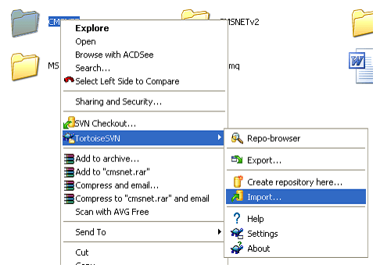

  - Confirmation window will display then click OK button.

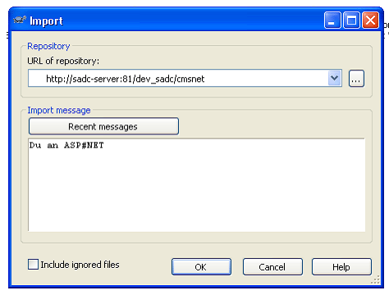
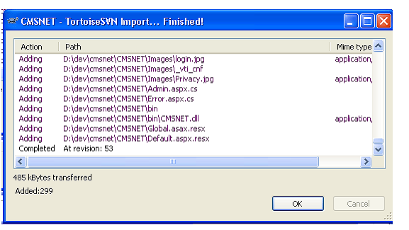

Add files to SVN
- Open Window Explore then select folder/files need be added to SVN then window confirm will display then select TortoiseSVN ➔ Add files… menu
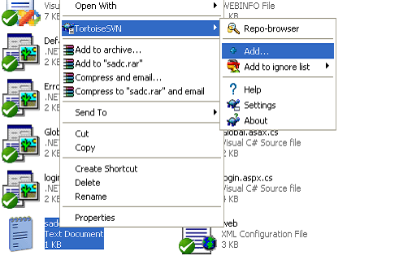
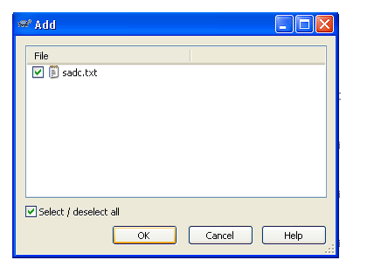

- Select “SVN Commit” menu to commit Add file action.

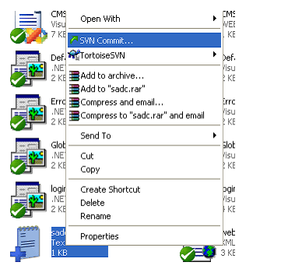

Manage file in SVN
- After add folder into Database of SVN,in SVN window files will display as lock bellow

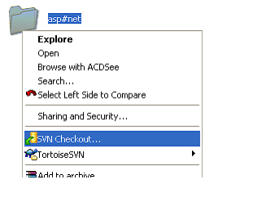
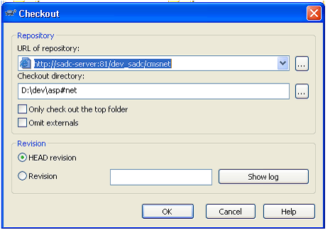
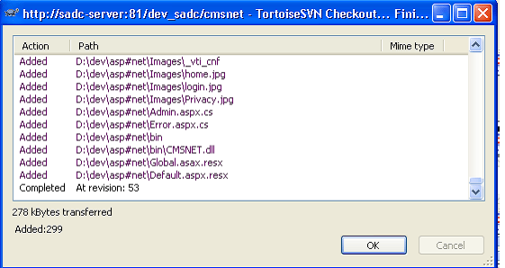
- After ensure exactly update content, we click right mouse then select “SVN Commit…” to save updated file into database of SVN. After commit action should write comments to define change content more easily in future so we can rollback previous version easyly.

- Check changed information of project & file.
+ If folder have not any change information icon will like that
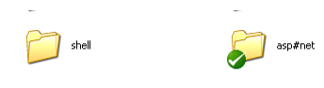

+ If folder have any change information icon will like that

+ Show changed file
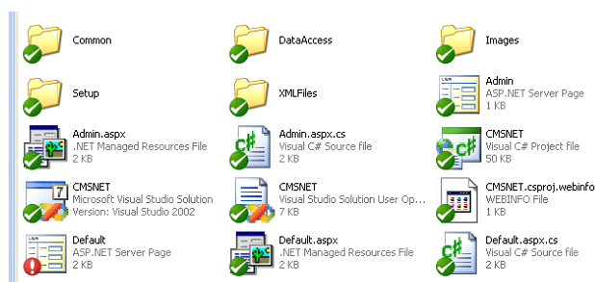
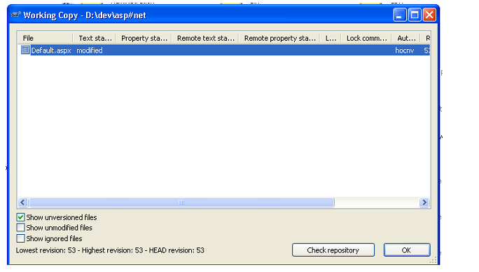
- View changed information by right click ... select "Compare with base"
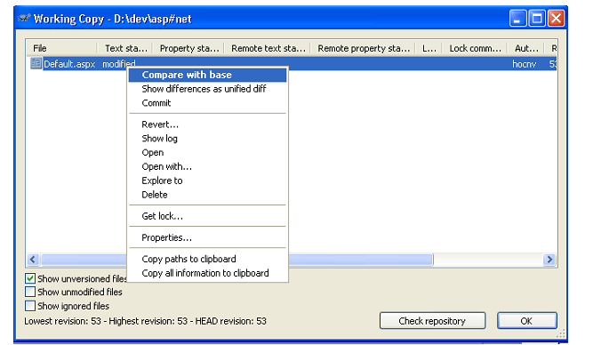
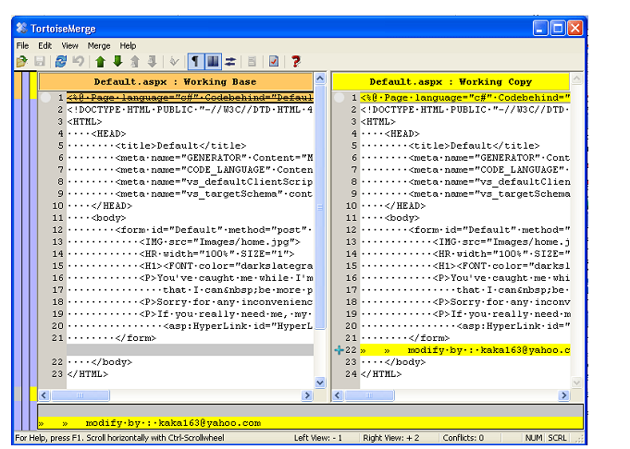

- To using previous version of file we need clik right mouse button of file in Solution window then select“Update to reversion...”.

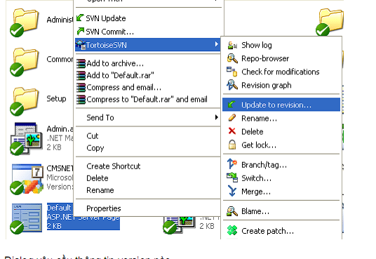

- History window will display, follow date time of versions, we will identify version need recovered then select and click ShowLog menu to back that version.
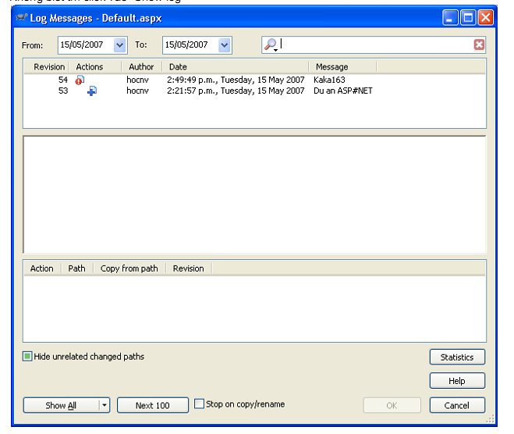
  - Select version then select Revision to rollback
